**Results for Larger Problem Instances**

To explore the limitations of the proposed hybrid approach in terms of convergence and optimality, larger-sized problems are generated and solved using the proposed method. As demonstrated in the sensitivity analysis, setting the number of scenarios to 200 yields results similar to those obtained with 300 or 400 scenarios. Moreover, the computational complexity analysis shows that the number of scenarios directly affects the solution time for the GACRFNI algorithm. Therefore, for the complex problem instances generated, the number of scenarios is set to 200, and the average metric values for these larger problems are presented in Table 1.

As shown in Table 1, the proposed algorithm delivers high-quality solutions within a reasonable computation time.

Additionally, Figure 1 illustrates the convergence curves for the three cases obtained by the GACRFNI algorithm for larger-sized problems, where the number of iterations is set to 600. The convergence curves are drawn for the largest problem, where $|C|=12$, $|W|=18$, and $|P|=24$. Figure 1(a) shows the convergence curve for Case-1, while (b) and (c) correspond to Case-2 and Case-3, respectively. From each of these figures, it is evident that the algorithm begins to converge after approximately 400 iterations.

It can be concluded that the proposed solution approach yields high-quality solutions even with a lower number of scenarios, which directly reduces the computational time, as shown in the computational complexity section. Therefore, it is possible to achieve high-quality solutions for larger problems within a reasonable amount of time, thanks to the high performance of the proposed approach, even with a reduced number of scenarios.

**Table 1** Computational results for larger sized problem instances

|  |  |  |  |  |  |  |  |  |  |  |  |  |  |
| --- | --- | --- | --- | --- | --- | --- | --- | --- | --- | --- | --- | --- | --- |
| **|C|** | **|W|** | **|P|** | **FF** | **TSOC (%)** | **ETWOC (%)** | **ETDC (%)** | **ETSC (%)** | **TNOS** | **ENTOW** | **ETS (%)** | **TNSSO** | **ENDSO** | **CPU** |
| 8 | 12 | 16 | 852986 | 0.25 | 0.36 | 0.10 | 0.29 | 2.33 | 5.93 | 0.59 | 200.00 | 10.69 | 422.92 |
| 8 | 12 | 20 | 915614 | 0.20 | 0.33 | 0.08 | 0.40 | 2.00 | 5.72 | 0.70 | 200.00 | 15.20 | 435.86 |
| 8 | 12 | 24 | 1089129 | 0.22 | 0.29 | 0.09 | 0.41 | 2.67 | 5.90 | 0.71 | 200.00 | 18.35 | 500.76 |
| 8 | 15 | 16 | 869930 | 0.18 | 0.44 | 0.08 | 0.30 | 1.67 | 7.53 | 0.64 | 200.00 | 11.51 | 431.09 |
| 8 | 15 | 20 | 955132 | 0.16 | 0.38 | 0.07 | 0.38 | 1.67 | 7.15 | 0.72 | 200.00 | 15.60 | 473.79 |
| 8 | 15 | 24 | 1072699 | 0.15 | 0.35 | 0.06 | 0.44 | 1.67 | 7.38 | 0.78 | 200.00 | 19.88 | 559.13 |
| 8 | 18 | 16 | 980281 | 0.19 | 0.47 | 0.08 | 0.26 | 2.00 | 8.86 | 0.62 | 200.00 | 11.21 | 478.39 |
| 8 | 18 | 20 | 1075146 | 0.17 | 0.42 | 0.06 | 0.35 | 2.00 | 8.73 | 0.74 | 200.00 | 16.09 | 533.85 |
| 8 | 18 | 24 | 1184923 | 0.15 | 0.39 | 0.06 | 0.40 | 2.00 | 8.91 | 0.77 | 200.00 | 19.69 | 651.63 |
| 10 | 12 | 16 | 838771 | 0.26 | 0.36 | 0.09 | 0.29 | 2.33 | 5.84 | 0.60 | 200.00 | 10.84 | 367.51 |
| 10 | 12 | 20 | 986987 | 0.25 | 0.31 | 0.09 | 0.35 | 2.67 | 5.85 | 0.65 | 200.00 | 14.32 | 439.50 |
| 10 | 12 | 24 | 1096864 | 0.21 | 0.29 | 0.08 | 0.42 | 2.67 | 5.96 | 0.72 | 200.00 | 18.38 | 522.51 |
| 10 | 15 | 16 | 892432 | 0.20 | 0.43 | 0.08 | 0.29 | 2.00 | 7.30 | 0.63 | 200.00 | 11.28 | 417.40 |
| 10 | 15 | 20 | 996750 | 0.18 | 0.39 | 0.07 | 0.36 | 2.00 | 7.44 | 0.70 | 200.00 | 15.17 | 496.27 |
| 10 | 15 | 24 | 1161825 | 0.21 | 0.33 | 0.08 | 0.38 | 2.67 | 7.30 | 0.72 | 200.00 | 18.52 | 579.90 |
| 10 | 18 | 16 | 977244 | 0.20 | 0.46 | 0.11 | 0.24 | 2.00 | 8.80 | 0.58 | 200.00 | 10.44 | 475.24 |
| 10 | 18 | 20 | 1069037 | 0.17 | 0.43 | 0.06 | 0.34 | 2.00 | 8.82 | 0.70 | 200.00 | 15.35 | 549.94 |
| 10 | 18 | 24 | 1169054 | 0.16 | 0.39 | 0.06 | 0.39 | 2.00 | 8.76 | 0.75 | 200.00 | 19.17 | 644.84 |
| 12 | 12 | 16 | 825263 | 0.22 | 0.37 | 0.09 | 0.31 | 2.00 | 5.91 | 0.62 | 200.00 | 11.13 | 374.69 |
| 12 | 12 | 20 | 979942 | 0.25 | 0.31 | 0.09 | 0.35 | 2.67 | 5.78 | 0.66 | 200.00 | 14.40 | 371.40 |
| 12 | 12 | 24 | 1120125 | 0.24 | 0.28 | 0.09 | 0.39 | 3.00 | 5.86 | 0.68 | 200.00 | 17.62 | 503.81 |
| 12 | 15 | 16 | 918920 | 0.22 | 0.42 | 0.08 | 0.28 | 2.33 | 7.37 | 0.60 | 200.00 | 10.93 | 431.50 |
| 12 | 15 | 20 | 1022685 | 0.20 | 0.37 | 0.08 | 0.35 | 2.33 | 7.14 | 0.67 | 200.00 | 14.75 | 488.53 |
| 12 | 15 | 24 | 1241815 | 0.23 | 0.31 | 0.11 | 0.35 | 3.33 | 7.17 | 0.66 | 200.00 | 17.19 | 594.11 |
| 12 | 18 | 16 | 1011136 | 0.22 | 0.44 | 0.11 | 0.23 | 2.33 | 8.69 | 0.57 | 200.00 | 10.41 | 474.38 |
| 12 | 18 | 20 | 1130434 | 0.22 | 0.40 | 0.08 | 0.31 | 2.67 | 8.69 | 0.67 | 200.00 | 14.68 | 515.09 |
| 12 | 18 | 24 | 1250450 | 0.18 | 0.38 | 0.08 | 0.37 | 2.67 | 8.82 | 0.72 | 200.00 | 18.56 | 620.50 |
| **Overall** | | | **1025392** | **0.20** | **0.37** | **0.08** | **0.34** | **2.28** | **7.32** | **0.67** | **200.00** | **14.86** | **494.61** |

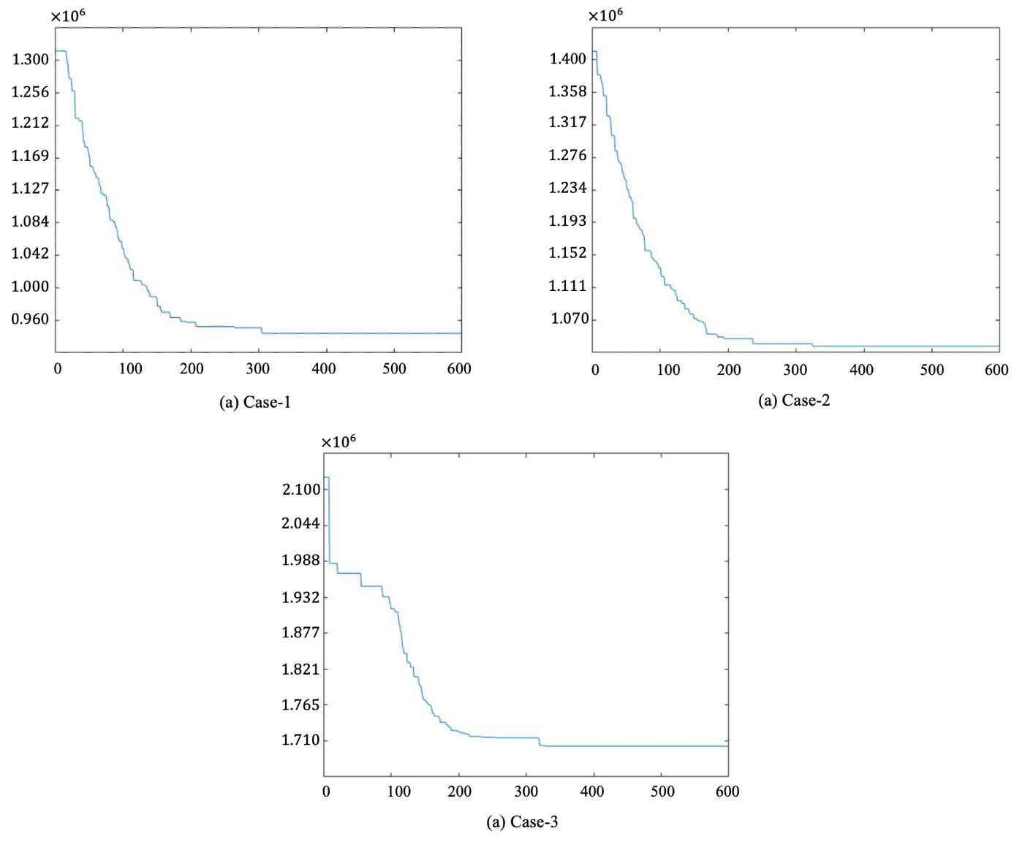

**Figure 1** Convergence curves obtained by GACRFNI approach for cases

The primary purpose of the RF model is to enhance the convergence speed and accuracy of the GA by predicting fitness values and guiding exploration. The performance of the RF model is assessed indirectly through the quality of the solutions generated by the GA. The high-quality solutions obtained using the GACRFNI and GACRFI approaches demonstrate the effectiveness of using RF for this purpose. Nevertheless, to directly assess the predictive performance of the RF model, the $R^{2}$ values are computed based on Equation (1) by considering the last iteration of the proposed approaches. For this assessment, 20% of the population obtained at the last iteration of the largest example (12×18×24) is used for testing purposes. The $R^{2}$ values are found to be 0.71 and 0.74 for the GACRFNI and GACRFI solution approaches, respectively.

|  |  |
| --- | --- |
| $R^{2}=1-\frac{\sum_{i=1}^{n}{{\left(y_{i}-\hat{y_{i}}\right)}^{2}}}{\sum_{i=1}^{n}{{\left(y_{i}-\overline{y_{i}}\right)}^{2}}}$ | (1) |

These results indicate that even though the RF model contributes to the GA in finding high-quality results, its prediction performance should be enhanced. The RF model cannot explain all the variations in FF values with the considered input features. Therefore, it is suggested to increase the number of features by adding new ones directly related to the decision variables. It is also demonstrated that embedding machine learning algorithms into metaheuristic algorithms is a promising idea to improve solution quality. However, it is also crucial to enhance the prediction performance of the implemented machine learning methods.